**Rahul Adhao COP assignment 1**

Q-1 wap to demonstrate ternary operator .define a variable marks  .ask its value from user and using ternary operator check if marks > 40 store "Pass" in result varible else store "Fail

package assignment;

import java.util.*;

public class Question1 {

public static void main(String[] args) {

Scanner s=new Scanner(System.***in***);

System.***out***.println("enter number");

int a= s.nextInt();

int b=40;

String c=a<b ? "pass" :"fail";

System.***out***.println(c);

// **TODO** Auto-generated method stub

}

}

Output:-

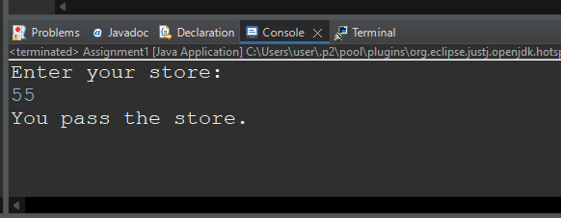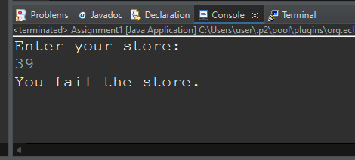Q 2 using ternary check if number entered by user is positive or negative .  
In case number is positive store "Positive number" else store negative number to Result variable

package assignment;

import java.util.Scanner;

public class Question2

{

public static void main(String[] args)

{

int num;

Scanner sc = new Scanner(System.***in***);

System.***out***.print("Enter a number: ");

num = sc.nextInt();

String c=num > 0 ? "positive" : "negative";

System.***out***.println(c);

}

}

Output

Enter positive value

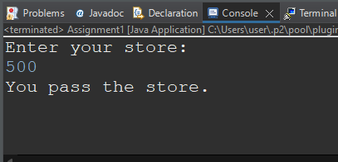

Enter negative value

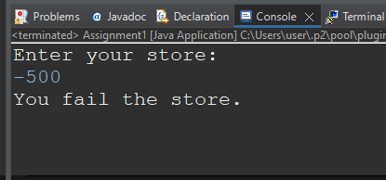

Q 3 WAP to ask name ,age and salary of an employee and print on console

package demo;

import java.util.*;

public class Question3 {

public static void main(String[] args) {

Scanner s =new Scanner(System.***in***);

System.***out***.println("Enter your name");

String name =s.nextLine();

System.***out***.println("Enter your age");

float age =s.nextFloat();

System.***out***.println("Enter your salary");

float salary =s.nextFloat();

System.***out***.println("name ="+name);

System.***out***.println("age="+age);

System.***out***.println("salary="+salary);

}

}

Output

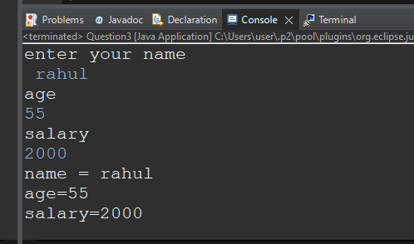

Q 4 wap  that ask two numbers from user and print greater number among two

package demo;

import java.util.*;

public class Question4 {

public static void main(String[] args) {

int num1, num2, largest;

Scanner scan = new Scanner(System.***in***);

System.***out***.print("Enter the First Number: ");

num1 = scan.nextInt();

System.***out***.print("Enter the Second Number: ");

num2 = scan.nextInt();

if(num1>num2)

largest = num1;

else

largest = num2;

System.***out***.println("\nLargest = " +largest);

}

}

Output

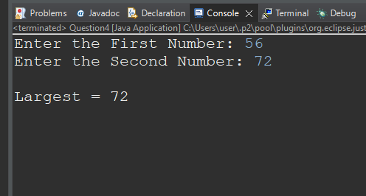

Q 5 wap to ask product name and price of product from user and calculate discount i.e   
if price > 2000 then discount is 10 percent of price   
else   
discount is 7 % of price

package demo;

import java.util.*;

public class question5 {

public static void main(String[] args) {

Scanner s =new Scanner(System.***in***);

System.***out***.println("enter product name : ");

String name = s.nextLine();

System.***out***.println("Enter product price :");

float price =s.nextFloat();

if(price >2000)

{

System.***out***.println("Discount on this product is :"+price/100*10+"Rs");

}

else

{System.***out***.println("Discount on this product is :"+price/100*7+"Rs");

}

}

}

Output

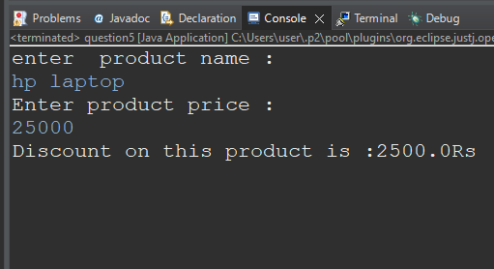

Q 6   Wap to swap two numbers

package demo;

import java.util.*;

public class Question6 {

public static void main(String[] args) {

int x, y, t;

Scanner sc = new Scanner(System.***in***);

System.***out***.println("Enter the value of X and Y");

x = sc.nextInt();

y = sc.nextInt();

System.***out***.println("before swapping numbers: "+x +" "+ y);

t = x;

x = y;

y = t;

System.***out***.println("After swapping: "+x +" " + y);

System.***out***.println( );

}

Output

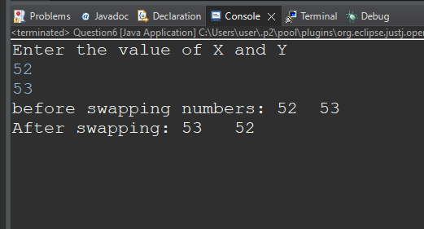

Q 7  How to swap two numbers without using a third variable?

package demo;

import java.util.*;

public class Question7 {

public static void main(String[] args) {

System.***out***.println("Enter the value of x and y");

Scanner sc = new Scanner(System.***in***);

/*Define variables*/

int x = sc.nextInt();

int y = sc.nextInt();

System.***out***.println("before swapping numbers: "+x +" "+ y);

/*Swapping*/

x = x + y;

y = x - y;

x = x - y;

System.***out***.println("After swapping: "+x +" " + y);

}

}

Output

Q 8 wap to check is number is even or odd.

package demo;

import java.util.*;

public class Question8 {

public static void main(String[] args) {

Scanner reader = new Scanner(System.***in***);

System.***out***.print("Enter a number: ");

int num = reader.nextInt();

if(num % 2 == 0)

System.***out***.println(num + " is even");

else

System.***out***.println(num + " is odd");

}

}

Output enter number 22

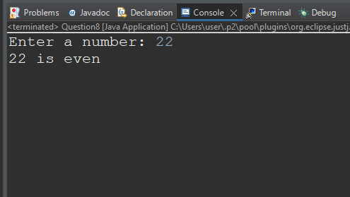

Enter number 21

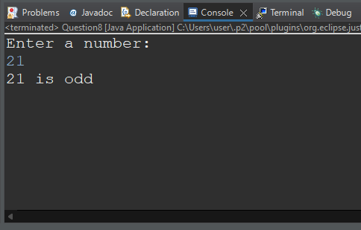

Q 9   A school has following rules for grading system:  
 a. Below 25 - F  
 b. 25 to 45 - E  
 c. 45 to 50 - D  
 d. 50 to 60 - C  
 e. 60 to 80 - B  
 f. Above 80 - A  
 Ask user to enter marks and print the corresponding grade

package demo;

import java.util.*;

public class Question9 {

public static void main(String[] args) {

Scanner s= new Scanner(System.***in***);

System.***out***.println("ENTER YOUR MARKS");

int marks=s.nextInt();

if(marks < 25)

System.***out***.println("F");

else if (marks>=25 && marks <45)

System.***out***.println("E");

else if (marks>=45 && marks <50)

System.***out***.println("D");

else if (marks>=50 && marks<60)

System.***out***.println("C");

else if (marks>=60 && marks <80)

System.***out***.println("B");

else if (marks>=80)

System.***out***.println("A");

else

System.***out***.println("you are fail");

}

}

Output

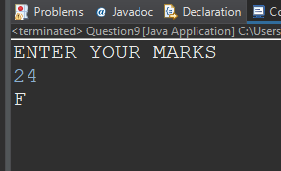

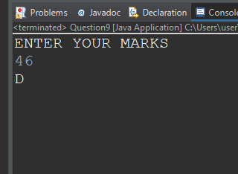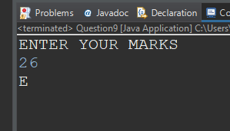

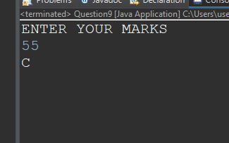

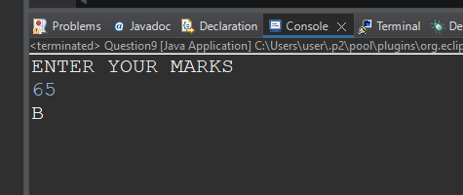

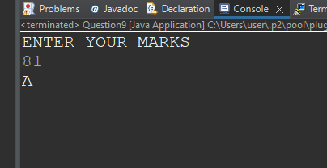

Q  10 wap to check greater number among three numbers

package demo;

import java.util.*;

public class Question10 {

public static void main(String[] args)

{

int num1, num2,num3, largest;

Scanner scan = new Scanner(System.***in***);

System.***out***.print("Enter the First Number: ");

num1 = scan.nextInt();

System.***out***.print("Enter the Second Number: ");

num2 = scan.nextInt();

System.***out***.println("Enter the third Number: ");

num3 = scan.nextInt();

largest= num3>(num1>num2? num1: num2)? num3 :((num1>num2)?num1:num2);

System.***out***.println("\nLargest = " +largest);

}

}

Output

